*535/2*

*Physics*

*Paper 2*

*2 ¼ hours*



**ACEITEKA JOINT MOCK EXAMINATIONS 2017**

**UGANDA CERTIFICATE OF EDUCATION  
PHYSICS**

**PAPER 2**

**TIME: 2 ¼ HOURS**

**Instructions:**

*Attempt five* ***(5)*** *questions.*

**Where applicable, use:**

*Acceleration due to gravity , g = 10ms-2*

*Density of water = 1000 kgm-3*

*Speed of light in vacuum, c = 3 x 108ms-1*

*Specific heat capacity of water, = 4,200 Jkg-1K-1*

*Specific latent heat of ice, = 336,000Jkg-1*

*Specific latent heat of steam, = 2,260,000Jkg-1*

1. (a) (i) State Bernoulli’s principle. (1)

(ii) With aid of a diagram describe the working of a carburetor. (5)

(b)

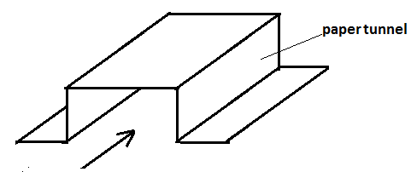

A piece of paper is folded in the shape shown above and air is blown into the tunnel as indicated by the arrow.

(i) Describe what is observed as air is blown in. (1)

(ii) Explain the observations above. (3)

(c) Explain why when a ball is hit and it and moves forward while spinning it may swerve to one side instead of moving straight. (3)

(d) Someone cautioned a friend that standing near a moving train is dangerous because a train has a magnet that pulls objects towards it. Use your understanding of physics to give the correct explanation. (3)

2. (a) (i) State the principle of conservation of energy. (1)

(ii) State the energy changes that take place in the internal combustion engine. (1)

(b) With aid of a sketch diagram describe the working of the four stroke petrol engine. (6)

(c) (i) Define specific heat capacity of a substance. (1)

(ii) 0.5kg of hot water at 100oC is contained in a cup of negligible heat capacity. Find out how much ice at 0oC should be added to the hot water to reduce its temperature to 20oC

(4)

(iii) Apart from its being cheap and available what is main reason why ice is used for cooling drinks? (3)

3. (a) (i) Define impulse. (1)

(ii) Explain why the damage to a building caused by slow moving trailer may be more than that caused by a fast moving car when it crushes into the building. (4)

(b) (i) Define momentum and state its SI unit. (2)

(ii) State the principle of conservation of linear momentum. (1)

(c) (i) Give the differences between elastic and inelastic collisions and give one example of each type of collision. (4)

(ii) A tennis ball moving at 60ms-1 hits a stationary volley ball that is twenty times its mass and bounces back with speed 10ms-1.

Find velocity of the volley ball after collision. (4)

4. (a) State what is meant by the terms:

(i) Internal resistance of a cell. (1)

(ii)Potential difference. (1)

(b) (i) State Ohm's law. (1)

(ii) Describe an experiment to determine internal resistance of a cell. (4)

(c) (i) Show that power dissipated in a resistor of resistance R in which current I is flowing is equal to is equal to I2R. (4)

(ii) An electric heater is made of two elements of resistance 40Ω each which can be switched to parallel or series connection to a 240V supply. Find out which connection gives maximum power. (5)

5. (a) Describe an experiment to show that a force acts on a wire that is placed in a magnetic field when current flows in the wire. (4)

(ii) State the factors that determine the amount of force on the wire. (3)

(b) Describe the construction and working of a simple d.c motor. (6)

(c) Name three ways of improving efficiency of the motor. (3)

6. (a) (i) Describe the nature of a sound wave. (2)

(ii) Describe an experiment to show that sound needs a material medium for its propagation. (4)

(iii) Describe how ultrasonic waves are used to determine depth of a sea. (3)

(b) (i) State what is meant by an echo. (1)

(ii) When sounding echoes the clapper was made to make 25claps per minute in order to make each clap coincide with the echo. Find distance of the clapper from the reflecting surface given that speed of sound in air on that day was 300ms-1. (3)

(c) List three differences between ultra-sound waves and X-ray waves. (3)

7. (a) Define the terms activity and half life of a radioactive material. (2)

(b) (i) Explain why precautions should be taken in presence of radioactive materials. (2)

(ii) State the conditions necessary for each of the reactions in (b) (i) to take place. (3)

(b) Name the three types of radioactive emission. (3)

(c) (i) A radioactive material produces some emission detected by a Geiger Muller Tube(GMT). Describe an experiment to identify the type of radiation emitted using absorbing materials. (4)

(ii) Outline the application of radioactivity in uptake of mineral salts in plants. (2)

8. (a) (i) State the conditions necessary for a body to in a state of mechanical equilibrium. (2)

(ii) State the principle of moments. (1)

(b) A uniform beam AB of negligible mass is supported on knife-edges at C and B as shown in the diagram. A mass m of 0.900kg is hanging on the beam at D. Find the reactions R1 and R2 at the knife-edges. (5)

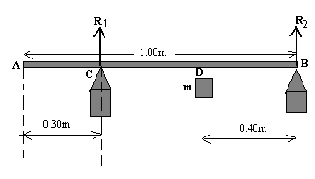

(c) A body of mass 100kg moving with initial velocity 15ms-1 is accelerated uniformly at a rate of 4ms-2 for 5 seconds. The body then maintains a constant velocity for an extra 8 seconds and is finally brought to rest in 7seconds.

(i) Sketch the velocity time graph for the motion. (2)

(ii) Calculate the momentum of the body during the 8th second. (3)

(iii) Calculate the retarding force that acted on the body. .(3)

**End**